**Cybersecurity 401**

**Module 3 - Security Operations**

**__________________________________________**

# **Lab 14 - Intrusion Detection and Prevention Systems (IDS/IPS)**

# 

**| Rodrigo Brasil 11/2023 |**

## **Part 1: Staging Traffic Mirroring, Snort**

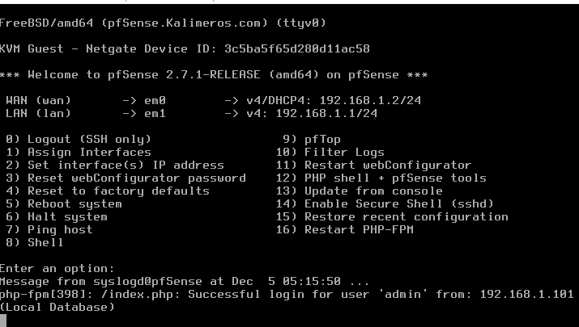

**pfSense VM** with the span port connected to the **Ubuntu VM**



**Ubuntu VM** with the span port connected to **pfSense VM**

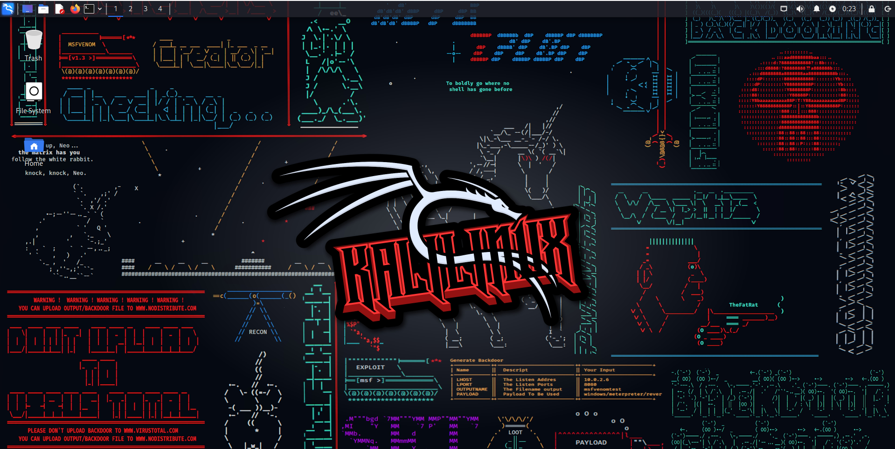

**Kali VM** to test if snort is detecting malicious traffic on the network

### 

### **Snort Install**

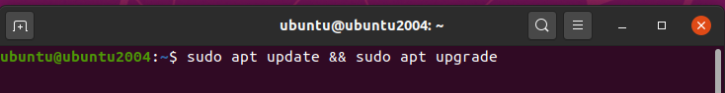

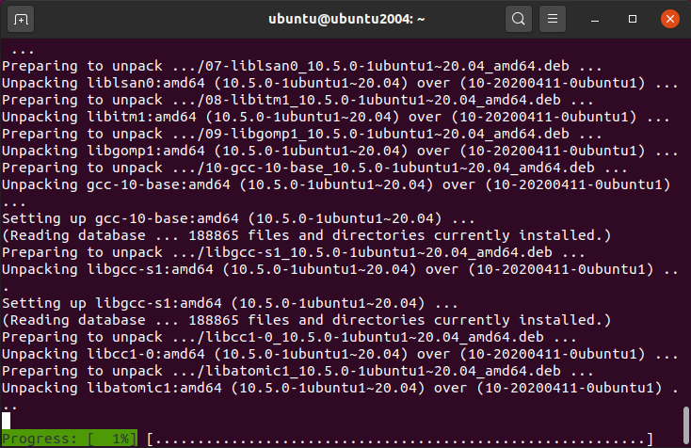

First we need to make sure ubuntu is updated

Using the command “**sudo apt update && sudo apt upgrade**” to update ubuntu

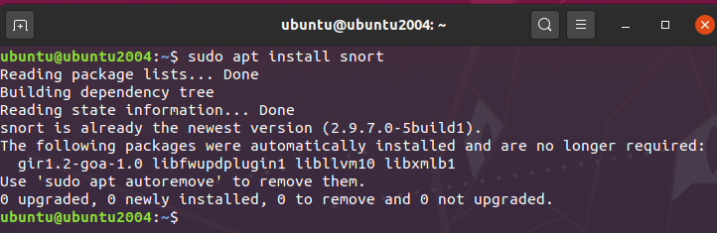

After updating we will use the command “**sudo apt install snort**” to install snort

On my case it’s already installed

**snort** is a free open source IDS (Intrusion Detection System) and IPS (Intrusion Prevention System)



After installing snort we need to initialize it.

To do so we use the following command “**sudo snort -c snort.conf -A console -i [network interface name]**”

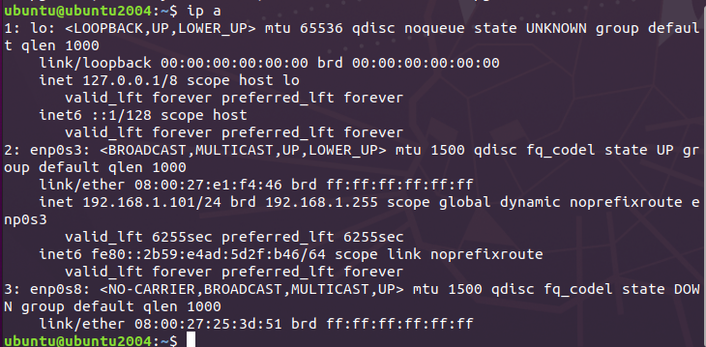

To know the network interface name, we simply use the command “**ip a**” to show our NIC

in my case its **enp0s3**

There may be a change an error will show up saying that the snort.conf file is not found

Its location is at /etc/snort use the command “**cd /etc/snort**” to get to its directory

if the file is not there, create it with the touch command “**sudo** **touch snort.conf**”

if the file is there, use the command “**sudo nano snort.conf**” to see it and save it

That fixed the issue for me

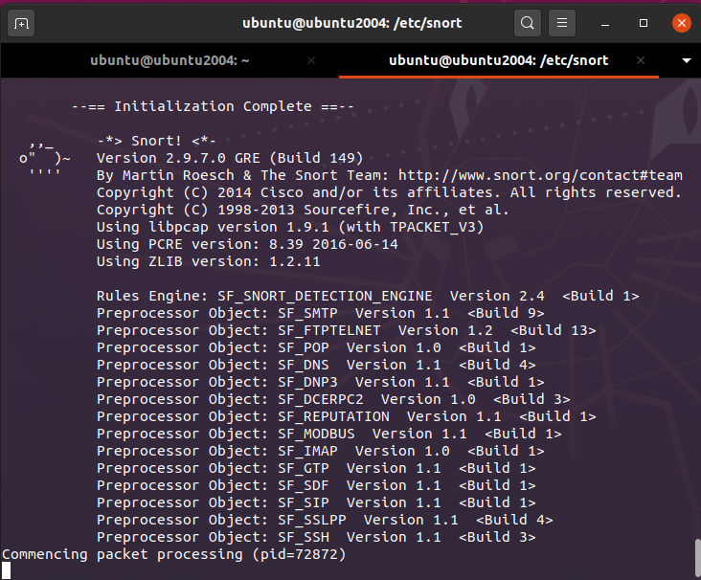

after initializing it, it will look like this

## 

## **Part 2: Detecting Network Activity with Custom Snort Rules**

### **ICMP packets rule**

Now to test snort we need to create a rule.

This rule we will create, will detect when ICMP packets are transmitted to Snort’s IP from the internet and raise an alert to the console.



to do so we need to navigate to snort config file which is located in the /etc/snort directory with the command “**cd /etc/snort**”



inside we will use a “**ls**” command to list what’s inside the directory

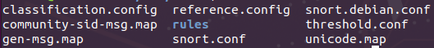

inside it we can locate the config file, its called **snort.conf**



Now to configure it we will use “**sudo nano snort.conf**”

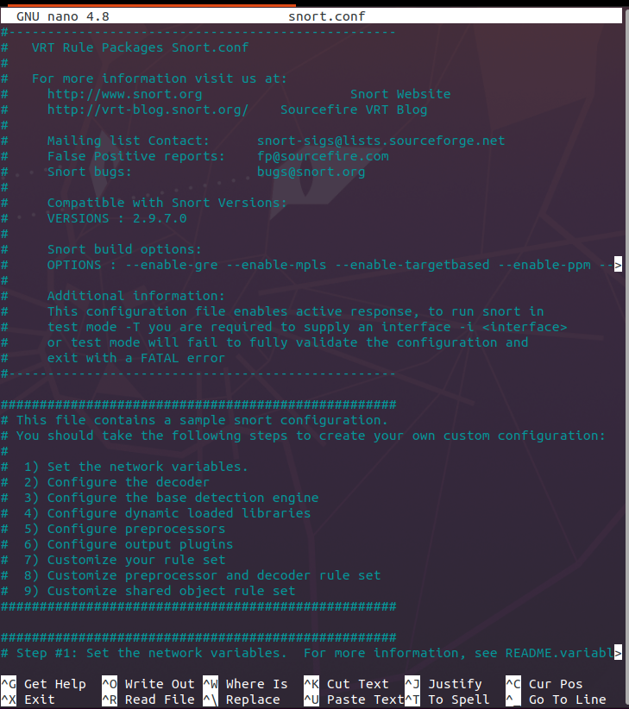

It will look like this

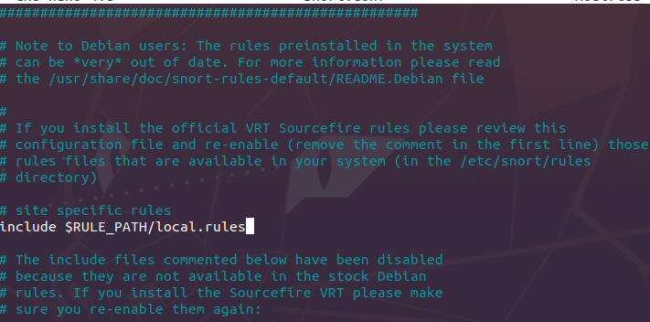

To add the new rule we need to find inside the config file the following string “**include $RULE_PATH/local.rules**”



To easily find it press **ctrl + w** and the search bar will appear

inside it, search for **local.rules**

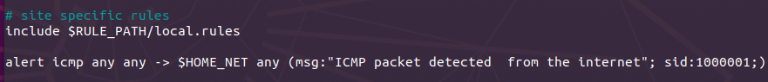

Under the string we will apply our rule

The rule will be “**alert icmp any any -> $HOME_NET any (msg:”ICMP packet detected from the internet”; sid:1000001;)**”

This rule will generate an alert for any ICMP packet coming from any source IP (any) to any destination IP ($HOME_NET, which is typically configured earlier in the file). The msg field contains the alert message, and sid is a unique identifier for the rule.



Now press **ctrl + o** to save the file, hit **enter**

and **ctrl + x** to exit the file

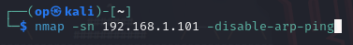

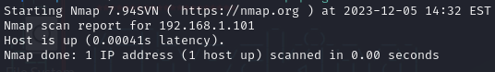

Now to test the rule, in kali we will use the following command “**nmap -sn 192.168.1.101 -disable-arp-ping**”

This command will perform a ping scan on the IP address “**192.168.1.101**” without using ARP ping.

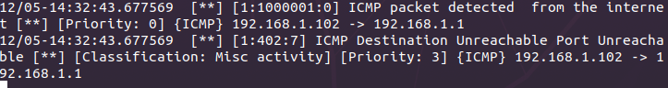

This is the result from snort

we can see the **kali VM** IP “**192.168.1.102**”

It seems snort is detecting the ping, giving us the message from the alert we setup and the source (192.168.1.102) and destination IP (192.168.1.1)

for some reason its is also giving an output that the ICMP destination is unreachable after, not sure why

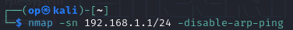

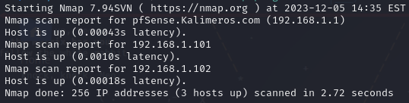

The command used before was for one host only, with this command:”**nmap -sn 192.168.1.1/24 -disable-arp-ping**”we are sending a ping to all of the hosts inside the CIDR block.

In this case was only 3 hosts

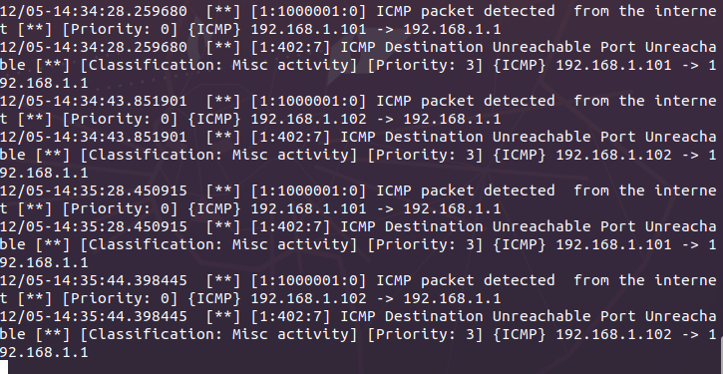

In here we can see the command activity sent by the **kali VM** being captured by snort

### 

### **FTP connection rule**

We are going to create a new rule

This rule we will create, will detect when an FTP connection is made from the internet and raise an alert to the console.



We will put the rule under the previously created rule.

The rule will be “**alert tcp $HOME_NET any -> $HOME_NET 21 (msg:”FTP connection detected”; sid:1000002;)**”

This rule will generate an alert for any FTP connection coming from any source IP ($HOME_NET any) to any destination IP on port 21 ($HOME_NET 21). Port 21 is the default port for the FTP protocol.

The msg field contains the alert message, and sid is a unique identifier for the rule.

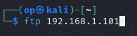

Now to test the rule we will use the **kali VM** again with the command “**ftp 192.168.1.101**”



and on snort it will appear our alert, with the source IP, the port 21 and the destination IP with the port as well.

### 

### **SSH connection rule**

We are going to create a new rule

This rule we will create, will detect when an SSH connection is made from the internet and raise an alert to the console.

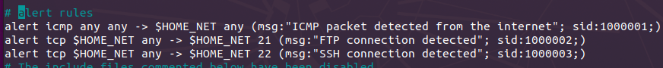

We will put the rule under the previously created rule.

The rule will be “**alert tcp $HOME_NET any -> $HOME_NET 22 (msg:” SSH connection detected”; sid:1000003;)**”

This rule will generate an alert for any SSH connection coming from any source IP ($HOME_NET any) to any destination IP on port 22 ($HOME_NET 21). Port 22 is the default port for the SSH protocol.

The msg field contains the alert message, and sid is a unique identifier for the rule.

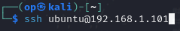

To test the rule we will try two different methods, one with ssh and another with the nmap tool.

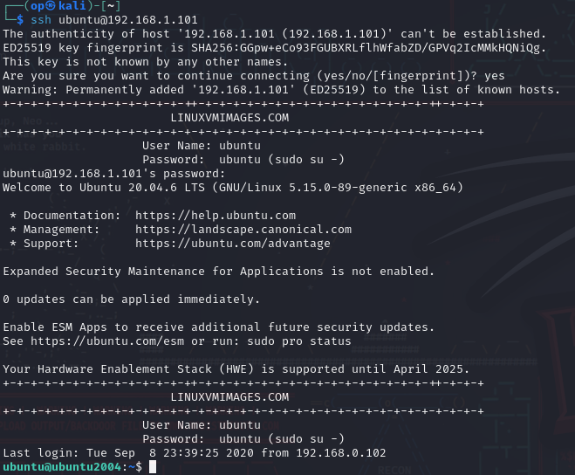

First one will be with ssh

With the command “**ssh ubuntu@192.168.1.101**”we make a ssh connection.

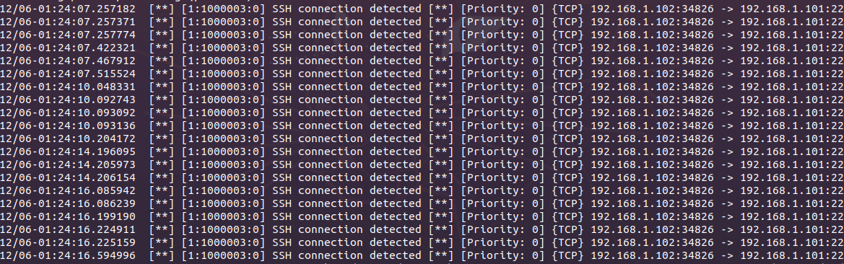

In the snort console we can see the ssh connection made with the kali VM

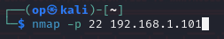

Now with nmap we will make a scan to the ssh port 22 in the ip 192.168.1.101

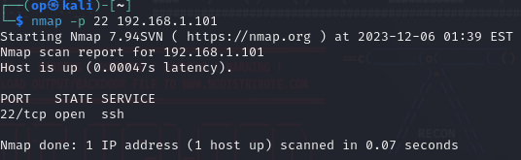

With the command “**nmap -p 22 192.168.1.101**” we make the scan

the scan tells us that the **PORT** 22 **STATE** is open and running the **SERVICE** ssh



On snort console it will show the alert of a ssh connection.

### 

### **HTTP connection rule**

We are going to create a new rule

This rule will detect when an HTTP connection is made from the internet and raise an alert to the console.

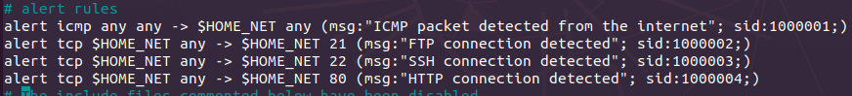

We will put the rule under the previously created rule.

The rule will be “**alert tcp $HOME_NET any -> $HOME_NET 80(msg:” HTTP connection detected”; sid:1000003;)**”

This rule will generate an alert for any HTTP connection coming from any source IP ($HOME_NET any) to any destination IP on port 80 ($HOME_NET 21). Port 80 is the default port for the HTTP protocol.

The msg field contains the alert message, and sid is a unique identifier for the rule

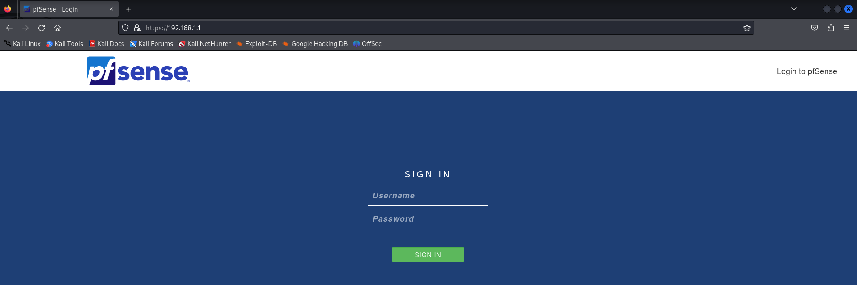

To test this rule we will simply connect to the **pfSense VM** config page with the ip “**192.168.1.1**”



In the snort console it will give us an HTTP connection alert

## **Part 3: Detecting Network Activity with Premade Snort Rules**

## 

First created an account on the snort website using a temporary email

and a random password generated by firefox

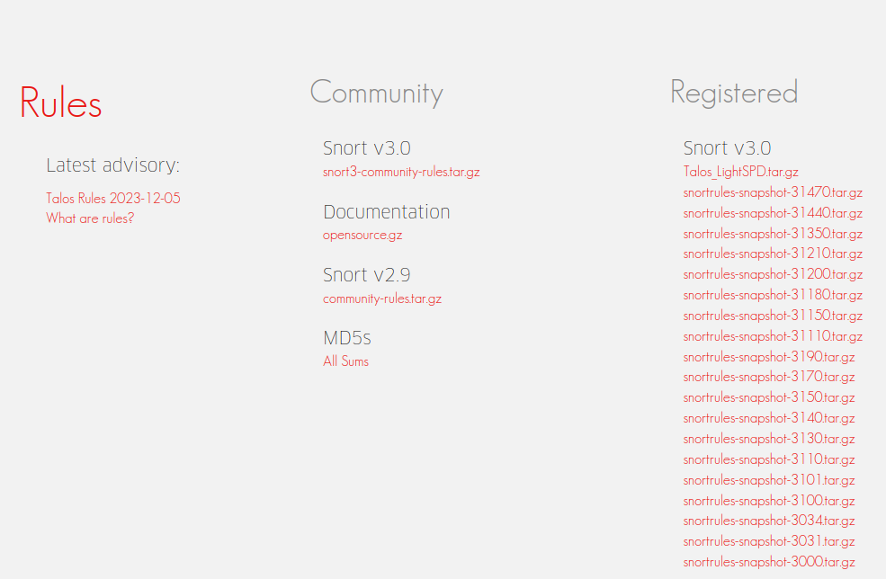

After logging in went to <https://snort.org/downloads/#rule-downloads> do download the rules

the one i downloaded was “**snortrules-snapshot-31470.tar.gz**”

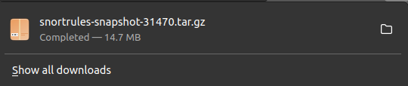

clicking the text it will download the zipped file

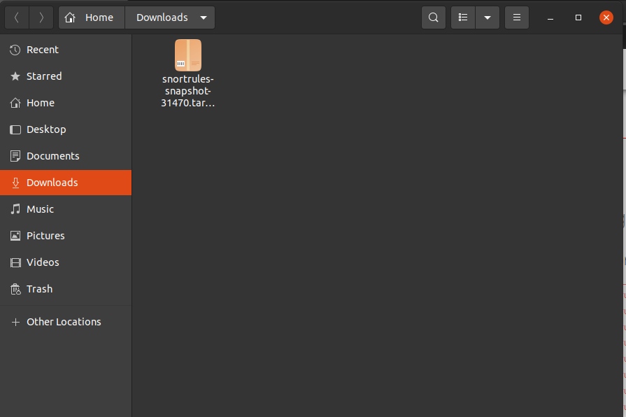

it will be located by the browser default at the Downloads directory

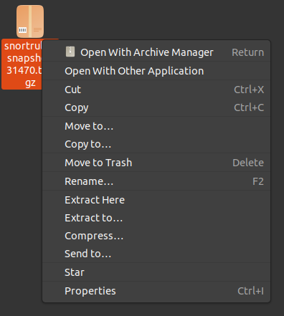

To unzip the file we right click it and select “**Extract Here**”

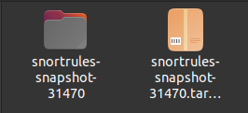

After extracting there will be a new directory called “**snortrules-snapshot-31470**”



In the terminal we navigate to the snort directory with the command “**cd /etc/snort**”

and use the ”**ls**” command to list what’s inside

inside it we can find the rules directory



to enter it we will use the command “**cd rules**”

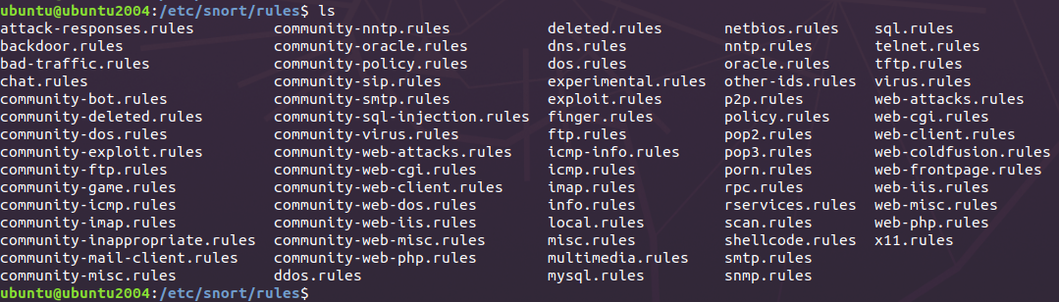

inside it there will be the rules that we have been using



To copy the new rules we download we will use the command

“**sudo cp ~/Downloads/snortrules-snapshot-31470/rules/* /etc/snort/rules**”

This command will copy the new rules we downloaded to snort rules directory

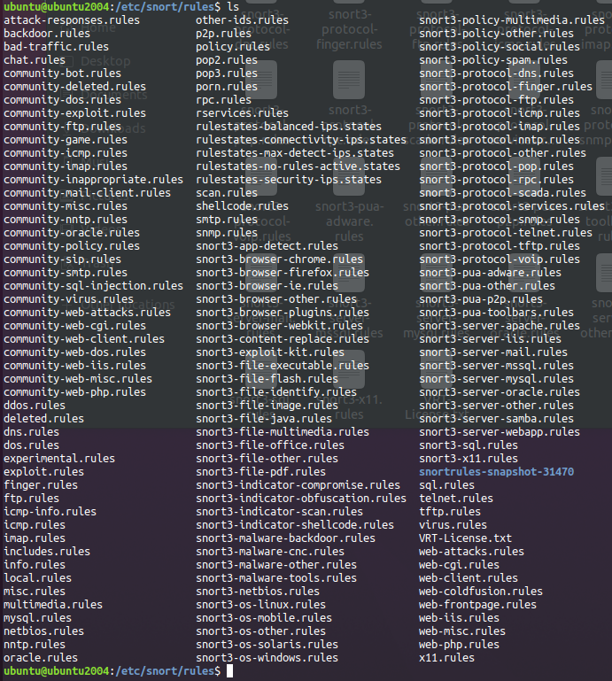

using the “**ls**” command we will see the newly added rules

Now to make this new rules work on snort we need to include them on the snort.conf file

## **Part 4: Reporting**

* How does Snort differ from a LAN firewall appliance?
  + Snort differs from a lan firewall in some ways like while a firewall controls traffic at the network, actively preventing unauthorized data. snort detects and prevents intrusions by analyzing network traffic based on customizable rules.
* Why would security teams deploy a NIDS solution?
  + Security teams would deploy NIDS solutions to enhance their ability to detect and respond to potential security threats within their network infrastructure.
* What are some limitations/shortcomings of a NIDS solution? In other words, what malicious activity would a NIDS not detect?
  + A NIDS solution would not detect zero-days or not yet added predefined signatures, so this means that if a new vulnerability has recently been discovered and the NIDS has not been updated it will not detect an attack using that new vulnerability.

### 